Short presentation on the following topic for the Groton Public Library Board of Trustees on 3.12.26. Presented by Elizabeth Honis, with input from the staff of Groton Public Library.

Public Library Service Model
What is a public library service model?
Public library service models, in essence, define how a library provides its services to the public, encompassing everything from physical spaces and collections to digital resources and community programs. These models are constantly evolving to meet the changing needs of the community and adapt to new technologies.
Key Aspects of Public Library Service Models
User-centered approach:
Focusing on the needs and preferences of the community members they serve.
Access to information:
Providing access to both physical and digital resources, including books, e-books, databases, and online research tools.
Community engagement:
Encouraging community involvement through programs, events, and outreach activities.
Digital literacy and technology:
Offering computer access, internet access, and assistance with technology skills.
Lifelong learning:
Supporting learning and information needs across all age groups and interests.
Physical space and collections:
Providing physical library spaces that are welcoming and conducive to learning, as well as collections of materials that meet the needs of the community.
Staff expertise:
Having skilled staff who can provide assistance with research, information literacy, and technology.
Outreach and partnerships:
Collaborating with other organizations and community groups to expand access and reach.

Examples of Service Models
Traditional model:
Focuses on physical and in-person assistance.
Library 2.0:
Emphasizes digital resources, online services, and user-driven initiatives.
Four Spaces model: (see the diagram below)
Aims to provide inspiration, learning, meeting, and performative spaces for users.
Roving and embedded reference models:
Reference librarians who rove throughout the library or are embedded in specific departments.
Beta spaces:
Collaborative spaces that encourage experimentation and user-driven innovation.
Information and literacy triage:
A model for underserved communities that focuses on meeting their specific needs.

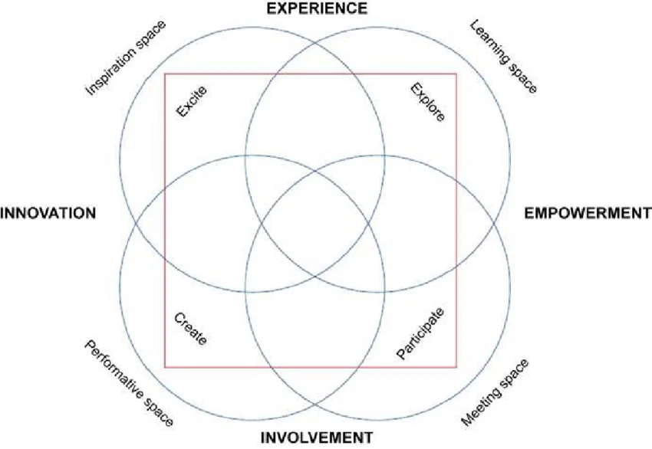
Jochumsen, Henrik & Hvenegaard Rasmussen, Casper & Skot-Hansen, Dorte. (2012). The four spaces – A new model for the public library. New Library World. 113. 5-5. 10.1108/03074801211282948.

